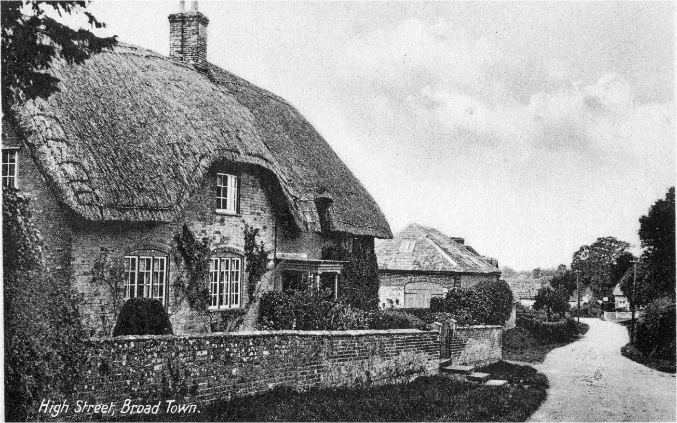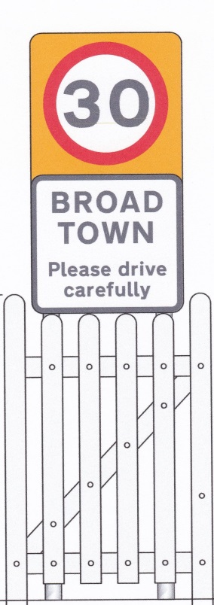

Broad Town – Illuminated Speed Limit Reminder Signs.

Introduction
Broad Town is situated on the C415 (former B4041). This important through route takes traffic from the A4361 to Royal Wootton Bassett and the M4. During rush hour and other busy times the volume of traffic is considerable. Broad Town also lies at the bottom of a steep hill (12%) on which the present 30mph speed limit starts and continues northwards through the village. There is an increase to the national speed limit whereby the road continues to Royal Wootton Bassett.
The problem the village faces is one of a significant number of vehicles exceeding the speed limits through the village. For those travelling north heavy braking is required coming down the hill before the restriction and for those going south, speed is often increased to provide momentum going up the hill. Broad Town is particularly vulnerable to speeding traffic. The school is situated directly on the main route and the fast moving traffic poses risk to those attending particularly at the beginning and end of the school day and during specific school activities.
The adopted Parish Plan showed speeding vehicles to be of great concern to villagers. A major concern of parish residents is the speed of the traffic along Broad Town Road and the consequential risk of accidents. 171 of respondents felt better traffic control measures were necessary and those receiving the greatest support were, in order:
- speed activated signs
- 20mph limit by school
- speed limits painted on the road
- extended 30mph zones
Of the items above the speed limit reminders have been painted on the road and village identity gates installed at the speed limit boundaries. The previous 40mph limit has been replaced with a 30mph limit. However despite these measures a recent metro count showed that very little has changed and that speeding through the village had not substantially reduced (see appendix B for detailed information on metro count results):
- MetroCounts undertaken in 2012 & 2017 demonstrate a 32% increase in the number of vehicles travelling through Broad Town daily
- The overall % of speeders varies from 15% to 29%
It is felt that speed activated signs and Speed Indicator Devices (generically referred to as SIDs) are a means to help reducing speeding through the village and should be explored. The Parish Council sought the advice of Wiltshire Council’s Highways Department and through the good offices of the Community Area Transport Group (CATG) a meeting was arranged with David Thomas of Wiltshire Council. At the meeting several objectives to improve road safety were discussed. It was felt that build outs were impractical in terms of cost and location. Fixed parking places are an alternative. The use of SIDS was discussed and the Parish Council agreed to consider how they could be installed and maintained. David confirmed that the project could be run entirely by the Parish Council.
Repeated issues have been raised since 2006 culminating in the latest live issue number 4567 (raised 29/03/2016). The Parish Council followed this up with a request for partial funding for the SID project from the CATG in June 2018. The CATG concluded that it is able to contribute towards the cost of the installation of a SID but not the running of the scheme or training. Certain criteria were also stipulated:
- SIDs should remain in one place for a short period (2-3 weeks) and then should be removed to avoid drivers becoming accustomed to them and ignoring them.
- SIDs need to be installed on suitable posts and the highways engineer has surveyed the area and provided recommendations for possible SID locations. The existing speed limit repeater posts would be suitable locations but the posts will need extending/replacing to allow the SID to be located at a suitable height.
- A management plan is required
The Parish Council has therefore decided to proceed with the purchase and installation of one illuminated speed limit reminder sign which can be moved to different locations within the 30mph zone.
The scheme will provide considerable benefit for the village and it will also provide a clear demonstration of local representatives and organisations working in partnership, and show Wiltshire Council’s and the Parish Council’s commitment to both road safety in the village and the implementation of the actions arising from the Parish Plan.

Broad Town Speed Limit Reminder Signs – Costs
Item | Qty | Unit Price | Total  (Ex VAT) |  |  |  | Total  (inc VAT)
Westcotec portable Diagram 670 30mph Speed Sign with SLOW DOWN legend beneath, battery powered complete with spare battery,‘intelligent’ charger, sign cover, clamps and data collection unit. | 1 | 2875 | 2875 |  |  |  | 3450
Additional brackets to facilitate easy installation | 4 | 50 | 200 |  |  |  | 240
Streetworks Accreditation training | 2 | 50 | 100 |  |  |  | 100
Supply and Install Posts (estimate from Wiltshire Council Highways) | 5 |  | 1051.55 |  |  |  | 1051.55
Total Project Cost |  |  | 4226.55 |  |  |  | 4841.55

Management Plan

Timetable
Broad Town Parish Council (BTPC) and CATG agree shared funding amounts | Spring 2019
Wiltshire Council will be contracted to supply and install the 5 extended posts at the agreed locations | Spring 2019
BTPC representatives achieve Streetworks Accreditation | Spring 2019
BTPC in conjunction with the Broad Town Community Speed Watch group procure the specified Speed sign device | Summer 2019
BTPC inform residents of speed sign commencement | Summer 2019
Speed signs installed | Summer 2019
Data collection and analysis | Summer 2019

Installation
- Four existing speed limit repeater posts will be extended and an additional post installed (Appendix A shows the locations which were agreed with the Wiltshire Council Highways Engineer).
- At least one Parish Council representative will be trained to achieve Streetworks accreditation and this person(s) will be responsible for the installation/removal of the device at each location.
- Broad Town Parish Council will own the speed sign device and be responsible for arranging insurance (the Westcotec device has a 3yr warranty, batteries 1yr warranty)

Safety Management
- A minimum of two people to be present when a device is being placed or removed, or batteries changed, with one person whose role is to watch over the operation including observing oncoming traffic.
- A mobile phone to be available with contact numbers to call for assistance if needed.
- Where it is reasonable to do so, the device shall be mounted at a height which does not require climbing on to any step or platform. Where there is no other suitable location we may recommend a higher mounting height up to 2.3m where the proposed location is adjacent to or above a footway. In this instance the Parish or Town Council will be required to understand the risks associated with installing and removing a SID at this height before confirming that they would like to proceed.
- Any vehicle used for transport to the location to be parked in a safe place. If it is possible to park safely on the road, this can help move passing traffic further away. This is especially important if it is necessary to work from a step or platform.
- High visibility clothing to be worn (minimum of long sleeved high visibility jacket). If working on uneven ground, boots with good ankle support to be worn.
- Where it is necessary to work off the ground, a platform or set of steps should be selected most suited to the location(s). The HSE toolkit for working at height can be found at http://www.hse.gov.uk/work-at-height/wait/intro.htm . Among the factors to consider are:
- The platform or steps must be free standing and self-supporting, not leant against a post or similar.
- Use individually adjustable feet or levelling mats to ensure stability where ground is uneven
- People using the steps or platform must be sufficiently fit and able to do so safely.

Function
- The speed sign device monitors the speed of oncoming vehicles and will display the 30mph roundel and a “SLOW DOWN” message towards any vehicle detected as exceeding 30mph. This functionality continues throughout the night although the brightness of the sign is dimmed during hours of darkness. | 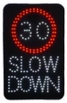
- The speed sign device captures the time and speed of all vehicles; the data can be downloaded to a PC when the device is removed at the end of the 2 week period.
- The device will be monitored at regular intervals to ensure it is operating and any failure will be reported to the Parish Council who will remove the device for investigation.

Data Gathering
- The downloaded data will be analysed to provide information on location, volume of traffic, % of speeders and speed detected, grouped by date and time.
- This information will be presented to the Parish Council at the monthly meeting and to the residents at the annual Parish meeting.

Objectives
It is important to note that the speed sign will not address concerns in the national speed limit parts of the village and is unlikely to influence the deliberate high end speeders seen overnight and at the beginning /end of the day. The ever increasing daily volume of traffic is also a concern. A long term goal should be set to assess and solve these three issues.
It is hoped that the deployment of the speed sign device will lead to a reduction in both the percentage of speeders and the excess speed detected.
The MetroCount data (see appendix B) indicates that the overall % of speeders varies from 15% to 29%, at speeds between 36 mph to 72 mph. We will be aiming for a reduction in both these figures, with this being confirmed by the data collected by the speed sign device.

Appendix A - Locations
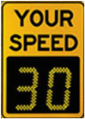
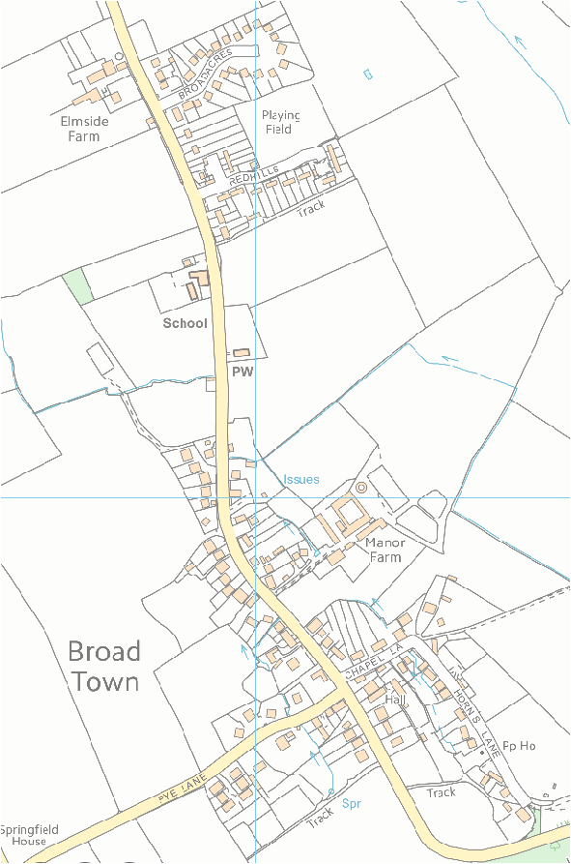
New Pole

Appendix B – Metrocount Data
A metrocount is carried out in order to assess the speed of traffic. Six metrocount surveys have been undertaken in Broad Town since 2010. However, as can be seen below the location of sites means we can’t directly compare metrocount statistics.
 | When | Why | Where | Outcome | Next steps
1 | 2010 | To assess whether Broad Town would be eligible for CSW. | 30mph by the Church | ??
2 | August 2012 | To assess the impact of the white gate & roundel project | 30mph by the Church | ??
3 | November 2012 | Requested by CSW to assess whether CSW could operate in the 40mph section of the village | 40mph by Broad Acres | 85th percentile was 41.2mph so not high enough to permit CSW to operate by Broad Acres
4 | April 2013 | Requested by Highways for the C415 Road Review | 60mph by Goldborough | Presumably the outcome was the removal of the 40mph by Broad Acres
5 | April 2013 | Requested by Highways for the C415 Road Review | 60mph on the top of the BT hill towards Broad Hinton | Presumably the outcome was the removal of the 40mph by Broad Acres
6 | October 2017 | It is not known who requested this metrocount or why it was requested | 30mph by the Village Hall | 85th percentile was 39.8mph | ??
There is some merit of comparing the studies undertaken in the 30mph part of the village (by the Church in 2012 and by the village hall in 2017).
Comparing the surveys undertaken in the 30mph part of the village we can see :
 | Daily # passing
2012 | 1470
2017 | 1937
¹Calculated by dividing total passing by number of days (NB partial days have been excluded)

The graph below shows the 2012 survey results undertaken by the Church. The actual 85%’ile recorded by metrocount shows higher speeds at the beginning and end of the day with the bulk of the daytime traffic hovering around the 35-38 %’ile.

In 2017 the data has been split by North or South direction (this was not provided for the 2012 survey). The graphs below shows the 2017 survey results undertaken by the Village Hall. The actual 85%’ile recorded by metrocount for traffic travelling south shows higher speeds at the beginning and end of the day with the bulk of the daytime traffic hovering around the 39-41 %’ile. It is interesting to see the traffic travelling north doesn’t seem to have the evening/night peak of excessive speeding and the overall daytime traffic hovering around the 36-39 %’ile.

